PRESS RELEASE - For Immediate Release
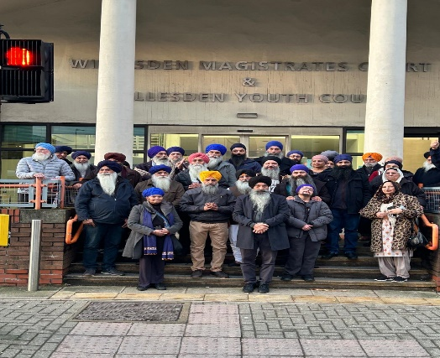

Waheguru Ji Ka Khalsa, Waheguru Ji Ki Fateh
VICTORY: Crown Court Re‑Affirms Gurmat Rehat Maryada
of Dhan Dhan Sri Guru Granth Sahib Ji
On 28th January 2026 With the grace and protection of Dhan Dhan Sri Guru Granth Sahib Ji Maharaj, the blessings of Sri Akal Takhat Sahib, Sant Mahapurakhs, Panthic Prabandhaks, and the unwavering support of the Sadh Sangat, we share this moment with deep humility and heartfelt gratitude.
Today, the Crown Court delivered a Not Guilty verdict in the case brought by a Hindu Mandir regarding the respectful removal and transfer of Sri Guru Granth Sahib Ji following serious concerns of beadbi and clear breaches of Gurmat Rehat Maryada. All three individuals charged have been fully acquitted.
This judgement is a landmark moment for the Sikh community, reaffirming both the legal and moral duty to uphold the highest standard of Satkar for Sri Guru Granth Sahib Ji.
This is not just a legal outcome — it is a testament to the Panth’s steadfast commitment to protect the honour of Guru Sahib Ji regardless of pressure or circumstance.
Words cannot express the depth of emotion felt today. Throughout all seven days of the trial, Sadh Sangat stood together in sehaj and sharda — with daily paat, simran, langar, seva, and unshaken support.
To every single person who offered ardas, time, presence, or strength: our heartfelt thanks. Your support became our shield, and your faith carried us.
This moment reminds us that when the Panth stands united in humility, truth, and devotion, Satguru Sahib Ji carries us through every storm.
We remain eternally grateful and pray that this decision brings peace, clarity, and renewed respect for the sanctity of Sri Guru Granth Sahib Ji across the world.
Waheguru Ji Ka Khalsa, Waheguru Ji Ki Fateh
END

